RAMANUJAN COLLEGE

UNIVERSITY OF DELHI



**DSE- INFORMATION SECURITY**

**PRACTICAL FILE**

**SUBMITTED TO:** Mr. Sahil Pathak Sir

**SUBMITTED BY:** Sukaina Inam Naqvi

**ROLL NO –** 20201426

**Examination Roll No.-** 20020570033

B.Sc. (H) Computer Science |   Vi Semester

Question 1. Implement the error correcting code.

Code:-

#include<iostream>

using namespace std;

int main() {

int data[10];

int dataatrec[10],c,c1,c2,c3,i;

cout<<"Enter 4 bits of data one by one\n";

cin>>data[0];

cin>>data[1];

cin>>data[2];

cin>>data[4];

//Calculation of even parity

data[6]=data[0]^data[2]^data[4];

data[5]=data[0]^data[1]^data[4];

data[3]=data[0]^data[1]^data[2];

cout<<"\nEncoded data is\n";

for(i=0;i<7;i++)

cout<<data[i];

cout<<"\n\nEnter received data bits one by one\n";

for(i=0;i<7;i++)

cin>>dataatrec[i];

c1=dataatrec[6]^dataatrec[4]^dataatrec[2]^dataatrec[0];

c2=dataatrec[5]^dataatrec[4]^dataatrec[1]^dataatrec[0];

c3=dataatrec[3]^dataatrec[2]^dataatrec[1]^dataatrec[0];

c=c3*4+c2*2+c1 ;

if(c==0) {

cout<<"\nNo error while transmission of data\n";

}

else {

cout<<"\nError on position "<<c;

cout<<"\nData sent : ";

for(i=0;i<7;i++)

cout<<data[i];

cout<<"\nData received : ";

for(i=0;i<7;i++)

cout<<dataatrec[i];

cout<<"\nCorrect message is\n";

if(dataatrec[7-c]==0)

dataatrec[7-c]=1;

else

dataatrec[7-c]=0;

for (i=0;i<7;i++) {

cout<<dataatrec[i];

}

}

return 0;

}

Output:-

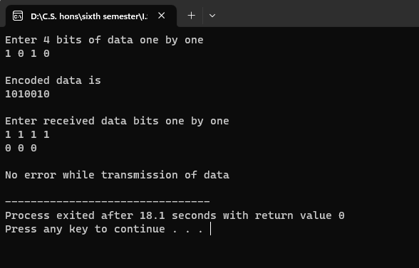

Question 2. Implement the error detecting code.

a.

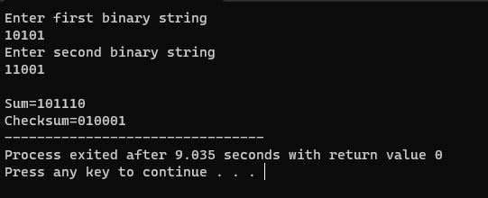

b.

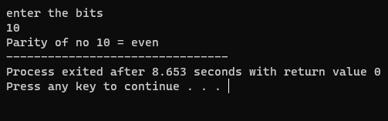

Question 3. Implement caeser cipher substitution operation.

Question 4. Implement monoalphabetic and polyalphabetic cipher substitution operation.

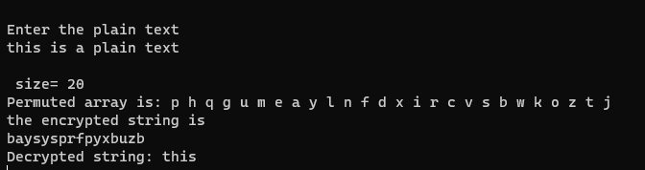

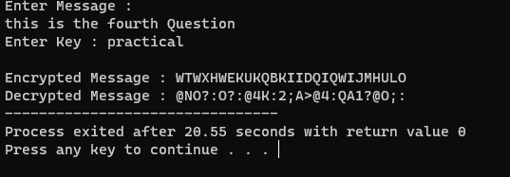

Question 5. Implement playfair cipher substitution operation.

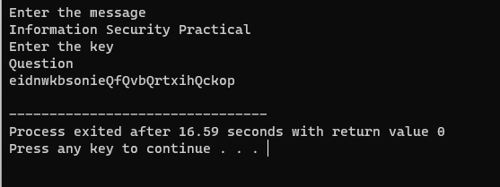

Question 6. Implement hill cipher substitution operation.

Question 7. Implement rail fence cipher transposition operation.

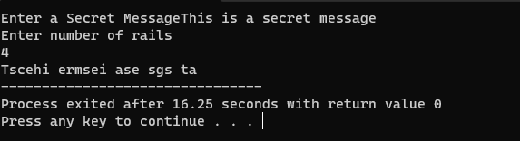

Question 8. Implement row transposition cipher transposition operation.

Question 9. Implement product cipher transposition operation.

Question 10.Illustrate the Ciphertext only and Known plaintext attacks.

Question 11.Implement a stream cipher technique